Assembly Instructions

Group 14

# Parts

|  |  |
| --- | --- |
| Box Top | Box Base |

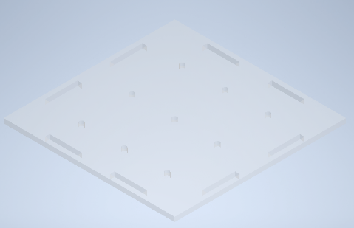

|  |  |  |  |
| --- | --- | --- | --- |
| Box Side 1 | Box Side 2 | Box Side 3 | Box Side 4 |

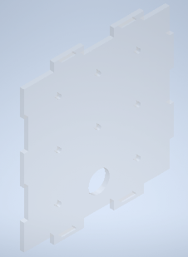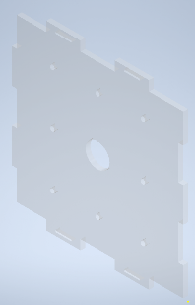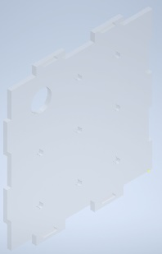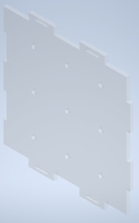

|  |  |  |  |  |
| --- | --- | --- | --- | --- |
| Entry Ramp | Exit Ramp | Coupling | Cam | Follower |

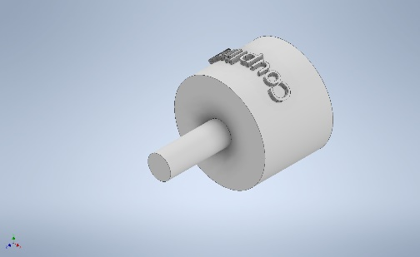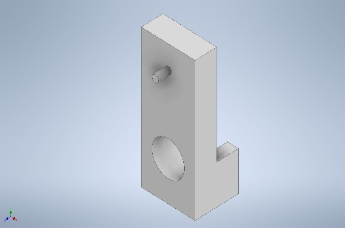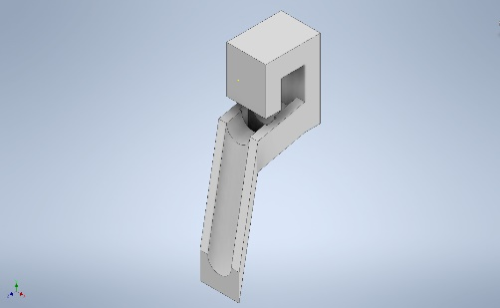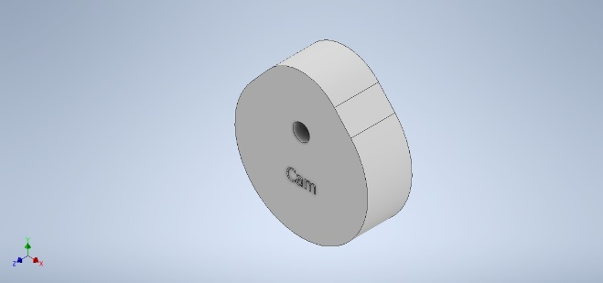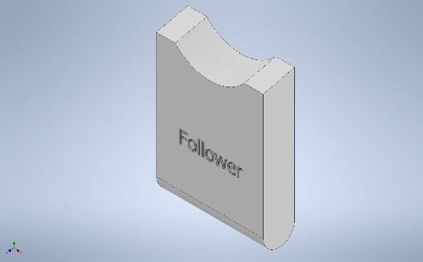

|  |  |  |  |  |  |
| --- | --- | --- | --- | --- | --- |
| Gear 1A | Gear 1B | Gear 2A | Gear 2B | Steel Shaft 1 | Steel Shaft 2 |

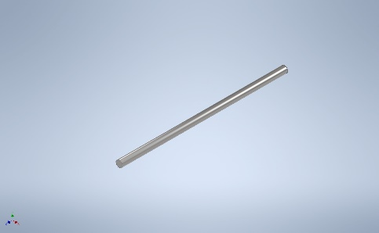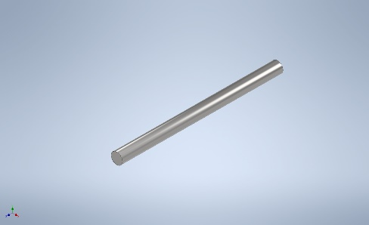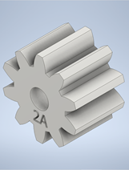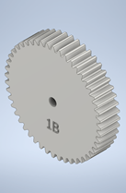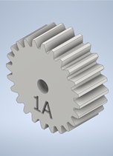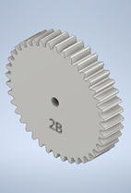

|  |  |  |  |
| --- | --- | --- | --- |
| Support 1A | Support 1B | Support 2A | Support 2B |

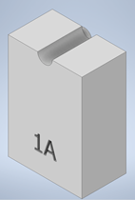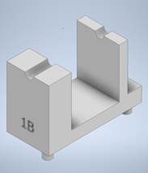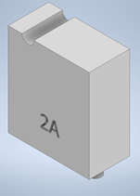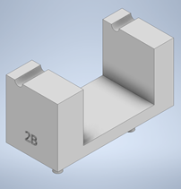

|  |  |  |  |  |  |  |  |  |  |  |  |
| --- | --- | --- | --- | --- | --- | --- | --- | --- | --- | --- | --- |
| Step 1: Apply Glue to Entry Ramp Using the Entry Ramp apply glue to the red shaded area shown in Figure 1. | Figure | | | | | | | | | | |
| Step 2: Attaching Entry Ramp Slot the protruding cylinder from Entry Ramp into the hole of Box Side 4 indicated by the RED arrow in Figure 2. Ensure the two large holes align as shown by the BLACK arrow and set the part aside as shown in Figure 3 | Figure | | | | Figure | | | | | | |
| Step 3: Apply Glue to Exit Ramp Using the Exit Ramp, apply glue to the shaded area shown in Figure 4. | Figure | | | | | | | | | | |
| Step 4: Attaching Exit Ramp Slot the protruding cylinder from Exit Ramp into the hole of Box Side 2 indicated by the RED arrow in Figure 5. Ensure the two large holes align as shown by the BLACK arrow and set the part aside as shown in Figure 6. | Figure | | | | | Figure | | | | | |
| Step 5: Attaching Support 1A Insert the protruded cylinder of Support 1A into the hole of Box Side 1, as shown by the BLACK arrow in Figure 7. Ensure the teeth of Box Side 4 are match the BLUE circle. The two parts should match Figure 8. | Figure | | | | | Figure | | | | | |
| Step 6: Attaching Support 1B Insert the protruded cylinders of Support 1B into the second row of holes in the Base Plate as shown in Figure 9 and Figure 10. The result should match Figure 11.  Note: If the protruded cylinders don’t align with the holes on the Base Plate, rotate the Base Plate 90°. | Figure | Figure | | | | | | | | | Figure |
| Step 7: Attaching Support 2A Insert the protruded cylinder of Support 2A into the hole of the Base Plate as shown in Figure 12. Ensure Support 2A is on the LEFT side of Support 1B. The result should match Figure 13. | Figure | | | | | Figure | | | | | |
| Step 8: Attaching Support 2B Insert the protruded cylinders of Support 2B into the holes of the Base plate as shown in Figure 14. The result should match Figure 15. | Figure | | | | | Figure | | | | | |
| Step 9: Attaching Gear 2A Insert Gear 2A into Steel Shaft 1 (smaller one of the two) as shown in Figure 16. Measure 6.5mm from either end and apply glue to the RED area shown by the arrow in Figure 17. | Figure | | | | | Figure | | | | | |
| Step 10: Attaching Gear 1B Insert Gear 1B onto the same shaft from Step 9: Attaching Gear 2A as shown in Figure 18. Measure 6mm from the other end and apply glue to the RED are shown by the arrow in Figure 19 | Figure | | | | | Figure | | | | | |
| Step 11: Attaching Gear 2B Insert Gear 2B into Steel Shaft 2 (larger one of the two) as shown in Figure 20. Measure 16mm from either end and apply glue to the RED area shown by the arrow in Figure 21. | Figure | | | | | Figure | | | | | |
| Step 12: Attaching the Cam Insert the Cam into the same shaft from Step 11: Attaching Gear 2B as shown in Figure 22. Measure 9.5mm from the other end and apply glue to the RED area shown by the arrow in Figure 23 | A picture containing metalware  Description automatically generated  Figure | | | | | A picture containing metalware, gear  Description automatically generated  Figure | | | | | |
| Step 13: Attaching Gear 1A Apply glue to the RED shade area of Coupling Figure 24. Insert the shaft into Gear 1A as shown in Figure 25. Let the glue set as shown by Figure 26. | Figure | | Figure | | | | | | Figure | | |
| Step 14: Combining the Box Side 1 Insert the teeth of Box Side 1 into slots of Box Base as shown by the BLACK arrows in Figure 27. The result should match Figure 28. | Figure | | | | | | Figure | | | | |
| Step 15: Placing Steel Rod 1 & 2 Place assembled Steel Shaft 1 from Step 10: Attaching Gear 1B onto the grooves of Supports 1A and 1B as orientated in Figure 29. Similarly Place assembled Steel Shaft 2 from Step 12: Attaching the Cam onto the grooves of Supports 2A and 2B as orientated in Figure 30. | Figure | | | | | | Figure | | | | |
| Step 16: Attaching Gear 1A to the Input Place and hold the assembly of Gear 1A from Step 13: Attaching Gear 1A onto Gear 1B so that they mesh together as shown in Figure 31. Whilst holding, take the input of your choice and pass it through the hole of Box Side 1 and connect with the assembly of Gear 1A as shown in Figure 32. | Figure | | | | | | Figure | | | | |
| Step 17: Combining Box Side 2 Insert the teeth of Box Side 2 into the slot of Box Base as shown by the BLACK arrows in Figure 33. Ensure the teeth and slots circled in RED are aligned properly. The result should match Figure 34. | A picture containing text, electronics  Description automatically generated  Figure | | | | | | A picture containing toy, LEGO  Description automatically generated  Figure | | | | |
| Step 18: Inserting the Follower Insert the Follower into the assembly of Entry Ramp from Step 2: Attaching Entry Ramp as shown in Figure 35. | Figure | | | | | | | | | | |
| Step 19: Combining Box Side 4 Hold the Cam shown in red in Figure 36 with your thumb so it doesn’t fall out, and slot the teeth of Box Side 4 into the Box Base as shown in Figure 37. Ensure the teeth circled in RED are aligned properly. The result should match Figure 38 with the Entry and Exit Ramp aligning with each other. | Figure | | | Figure | | | | | | Figure | |
| Step 20: Combining Box Side 3 and Box Top Insert the teeth of Box Side 3 into the Box Base as shown by the BLACK arrows in Figure 39. Ensure the teeth encircled in RED align properly. Similarly Insert the teeth of Box Top into the other 4 Box sides as shown in Figure 40. | Figure | | | | | | | Figure | | | |

## There you have it, the complete Box!

